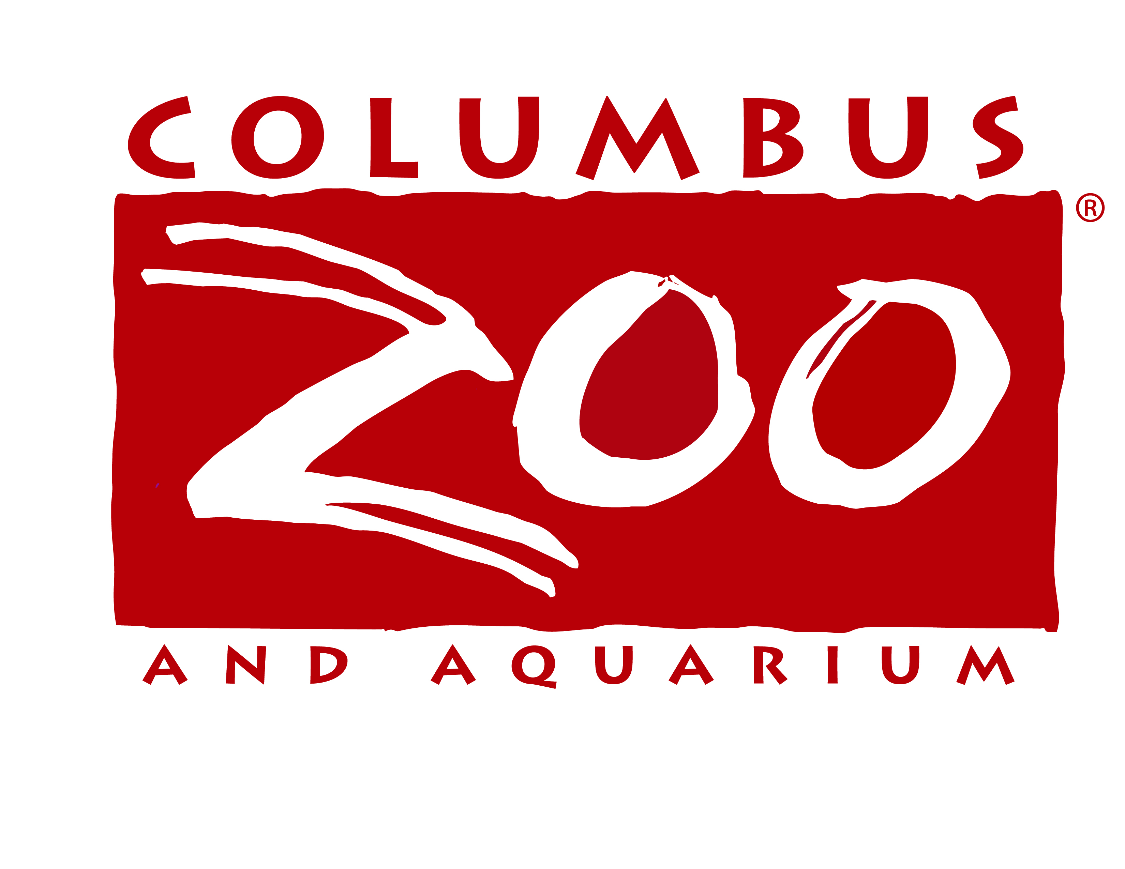

INFORMATION TECHNOLOGY DIRECTOR

The Columbus Zoo and Aquarium is seeking a full-time IT Director in its Information Technology Department. This position will manage all aspects of the IT organization including but not limited to: service delivery and support processes, trouble shooting of hardware and software problems, department budget, research, planning and implementation of all hardware and software changes and vendor relationships and agreements. Viable candidates must have a bachelor’s degree in computer science or a related field. An understanding of IT operations management, current technologies, and standard practices is also required with three to five years of experience as an IT manager preferred. Must be able to work a flexible schedule including evenings, weekends and holidays. The Zoo is a drug-free workplace that offers a fantastic benefits package, including OPERS retirement, a competitive salary and a unique work environment!

Deadline for application is Friday, December 19, 2008.

Please apply on-line at www.columbuszoo.org or send resume with salary history to:

Columbus Zoo and Aquarium
Human Resources Department
P.O Box 400
Powell, OH 43065
Fax: 614-645-3599

EOE

